FriendBook

# Overall Concept

Facebook! Just not as feature rich. This website will let users sign up, find their friends, and post updates about their lives. Users can post photos and text status updates and reply to their friend’s posts.

* Unauthenticated users that land on the site will see the signup page
* Authenticated users:
  + Land on their own home page and see all posts from their friends sorted by the date they were posted
  + Can search for new friends
  + Can send friend requests
  + Can accept or reject friend requests
  + Can post a photo to their timeline
  + Can post a text status update to their timeline

# Pages

The site must have the following minimum set of pages / behaviour:

* **Landing Page**: New users, and users not signed in, land on this page and either enter their info to log in, or click a link to sign up.
* **Sign Up / Register Page**: This page lets a user sign up.
* **Forgot Password Page**: Clicking forgot password on the login page takes you to the forgot password page. This page lets a user enter their email and the user is then emailed a link to reset their password.
* **Profile page**: A user enters all of their profile info after signing up and providers an image to use for their avatar.
* **Timeline page**: Authenticated users land on their timeline page. This page displays all of the user’s posts intermingled with the posting of their friends, ordered by the time they were posted. This page uses some mechanism to periodically refresh and check for new posts from the user’s friends.
* **New post page**: This page lets users post a photo or text status update to their timeline. Don’t worry about privacy / security settings, everything can be seen by all of a user’s friends.
* **Friends page**: This page lets a user add and remove friends. The user can search for friends, send friend requests and accept friend requests. They can also click on friends to see their profile.

# Landing Page

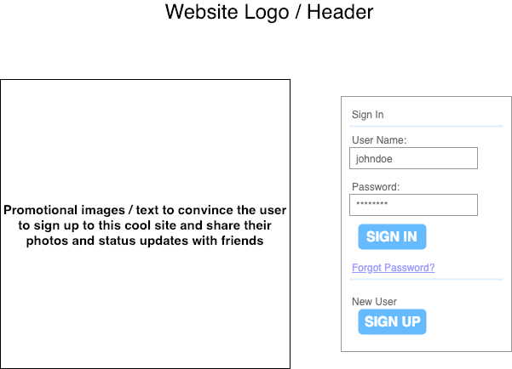

The landing page must:

* Advertise the capabilities of the site to convince users to sign up
* Allow users to log in:
  + Users login via combination of username/password. They can also use their email as their user name.
  + If the user doesn’t remember their password they can click a forgot password link and go to the forgot password page.
* Allow users to sign up via a link to the sign up page.

# Sign up / Register Page

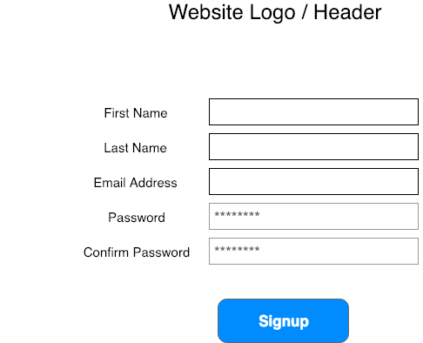

The sign up / register page must:

* Gather the following information from a user:
  + First Name
  + Last Name
  + Email address (must be unique in the database)
  + Password (must conform to some password rules, excellent candidate for configurable business logic)
* If a user’s passwords do not match or the user’s email address is already used by an existing user appropriate error messages should be displayed next to the fields when the user hits signup.
* If the user’s data is correct, the user is entered in the database and then automatically logged in. They are then taken to the profile page to fill out their profile.

# Forgot Password Page

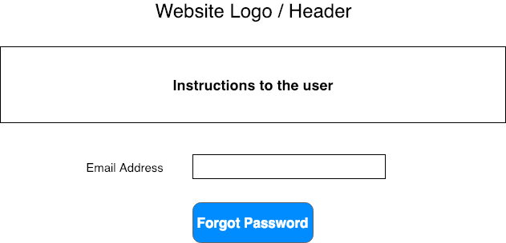

The forgot password page must:

* Prompt a user for their email address
* When the user enters their email address and clicks the “Forgot Password” button the following happens:
  + User is notified if their account exists they will be emailed with a link to reset their password, then redirected to the landing page.
  + If the account exists:
    - password is set to a random value
    - The user is emailed with a link that cannot be guessed by random users / hackers
  + If the user clicks the link in their email:
    - They are presented with a simple page that lets them reset their password by entering a new password (and confirming it in a separate box).
    - If the passwords match their password is changed, they are automatically logged in, and they are redirected to their timeline page.

# Profile Page

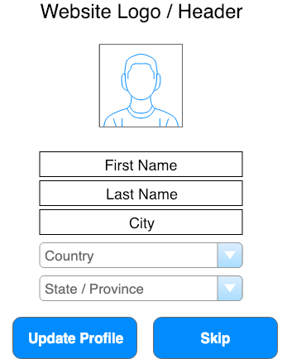

The profile page must:

* Pre-populate the first name and last name fields with their first and last name entered when they signed up or last changed their profile
* The user must enter their city
* The country dropdown is pre-populated with the current known countries.
* If Canada or United States are selected in the country drop down the state / province dropdown becomes enabled and is prepopulated with Canadian provinces or American states. If any other country is selected the state/province dropdown is disabled. Feel free to enable other countries as you like.
* Clicking the default generic icon allows the user to upload a photo for their profile picture / avatar.
* Clicking update profile saves the user’s changes and redirects to their timeline page
* Clicking skip cancels any changes to the user’s profile and redirects to their timeline page

# Timeline Page

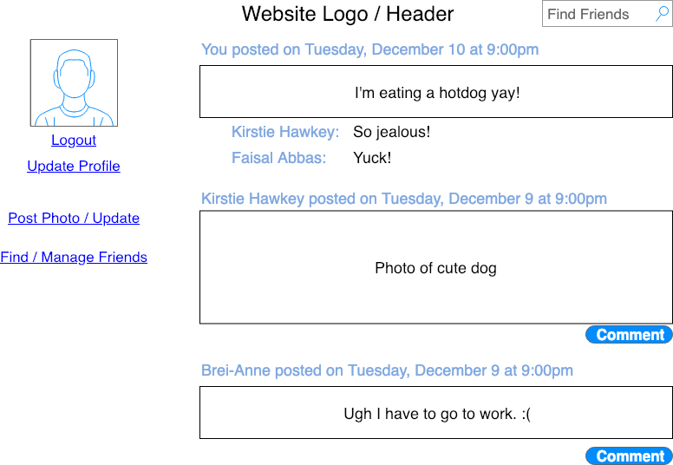

The timeline page must:

* Entering a name in the Find Friends box and pressing enter takes them to the friends page with a basic name search.
* Displays their avatar photo
* Allows them to logout (logout and return to landing page) or update their profile (link to update profile page).
* Click to post a photo or text status update
* Click to go to the friends page
* Display a timeline of posts:
  + Posts are displayed in the order they were created by any user (the user themselves, or their friends)
  + Posts automatically display all comments from other users
  + Posts from friends display a comment button and allow you to comment on their post.
  + Photo posts are resized / scaled to fit on the page, or if they are smaller than the spot, centered in a pleasing manner

# New Post Page

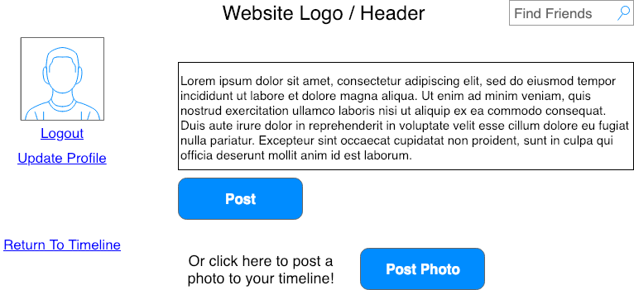

The new post page must:

* Display the user’s avatar image, a logout link and a link to the update profile page.
* Display link back to the user’s timeline.
* Display the simple friend search box, entering a name in the box and hitting enter takes the user to the friend management page with a simple name search.
* Allows the user to post a text status update to their timeline. All of their friends will display this post when they next load their timeline.
* Allow a user to upload a photo to be displayed on their timeline. All of their friends will display the photo when they next load their timeline.

# Friends Page

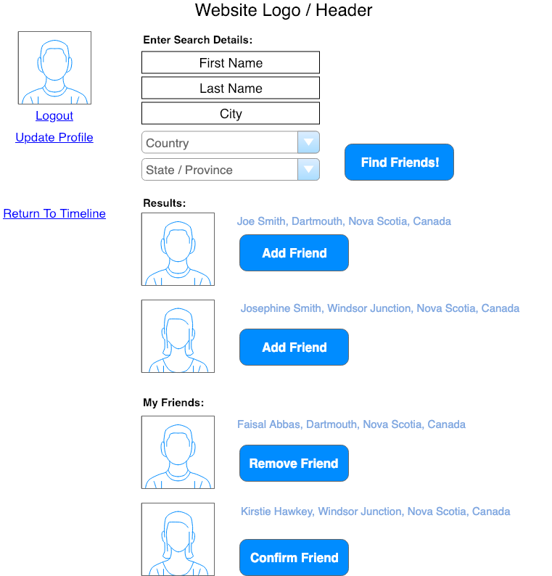

The friends page must:

* Display the user’s avatar photo and provide a logout link and a link to update their profile
* Display a link to return to the user’s timeline.
* Allow the user to search by any (or all) profile fields. The fields work the same as on the profile management page.
* If the user comes to this page from other pages via the friend search box, the first name and last name fields are prepopulated and the results section shows the results of searching by first name and last name.
* Results (if any) are displayed first with a button to send a friend request to the user.
* Existing friends are listed under “My Friends” with a button to remove friends. Removing a friend removes them from the list. When the user returns to the timeline page, posts from that friend will no longer show up in their timeline.
* Friend requests show up under “My Friends” with a button to confirm the friendship. Clicking the button makes both users friends. Posts from each user will show up in the other user’s timeline.